PROJECT REPORT

31st March 2026
SAKET SINGH
25BCE11055
B.Tech- CSE CORE
1st year
Digital literacy
CSE0001
INTRODUCTION

In today’s digital age, being digitally literate is essential for students to succeed academically and professionally. This project focuses on understanding digital literacy, including the use of digital tools, safe internet practices, email etiquette, and maintaining a professional online presence. It also highlights the risks of cybercrimes such as phishing and the importance of staying alert while using online platforms. Through this project, I explored how students can use technology responsibly and effectively in their daily lives. The aim is to create awareness and develop practical skills that help in safe, ethical, and efficient use of digital resources.

TASK 1 – Presentation

For my project, I used Microsoft PowerPoint to design a visual slide on digital literacy awareness. The design presents key aspects of digital literacy in a simple and organized format. It includes sections such as “What is Digital Literacy,” “Email Etiquette,” and “Safe Internet Practices.” Each section contains short explanations and bullet points to make the information easy to read and understand.
While creating the presentation, I found the clipart and design elements in PowerPoint very interesting, as they helped me represent ideas in a more creative way. Choosing suitable images for each section made the slide look more professional and attractive. However, one difficulty I faced was depicting cybercrime effectively through visuals. It was challenging to find cliparts that clearly represent concepts like online threats or hacking without making the design confusing or too complex.
Overall, this project helped me improve my skills in using PowerPoint and taught me how to present information clearly using both text and visuals.

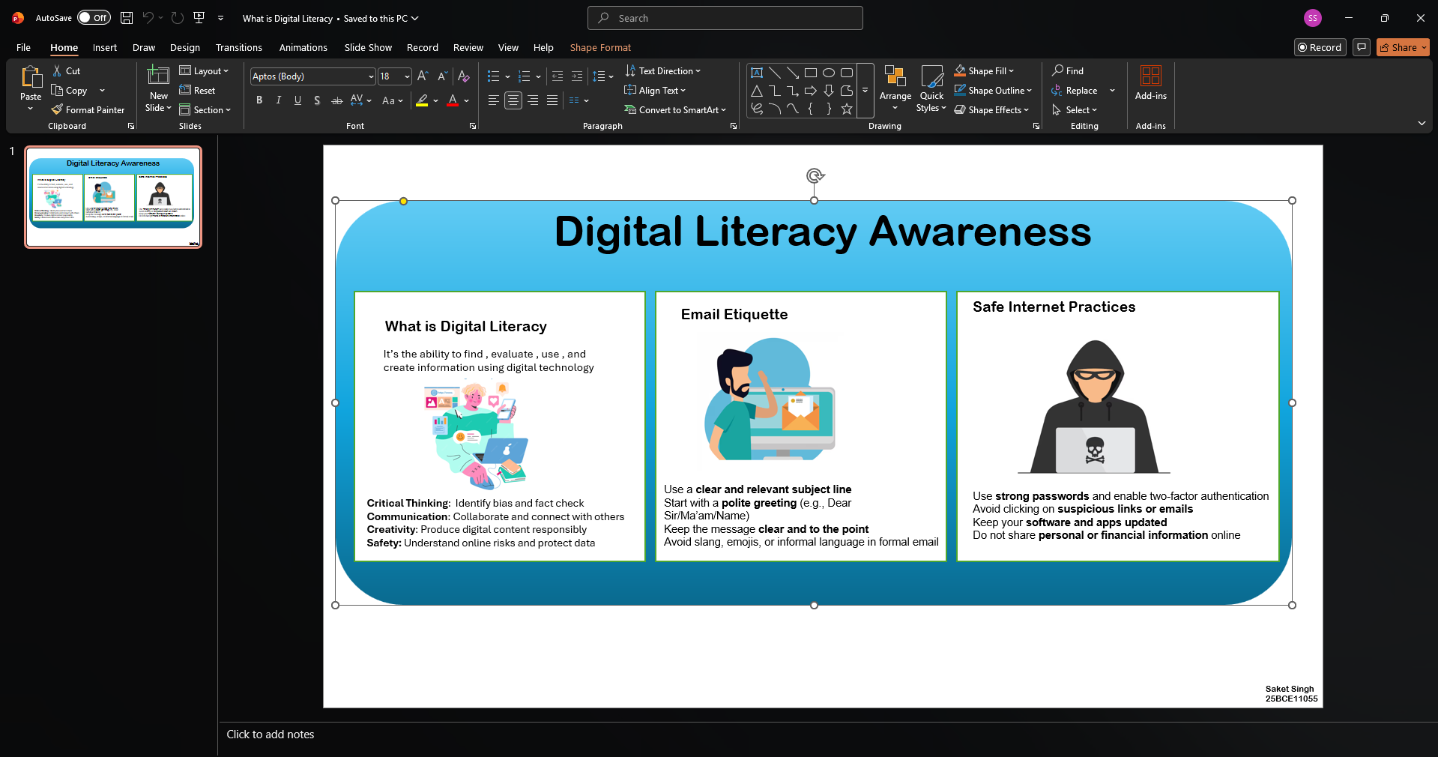

TASK 2 – Portfolio

For this task, I created and updated my profiles on GitHub, LinkedIn, and Stack Overflow. Each of these platforms serves a different purpose in a student’s academic and professional journey. GitHub is mainly used for hosting and managing code repositories, collaborating on projects, and showcasing programming skills. I also created a profile README on GitHub that includes my name, branch, year, and a brief statement about my learning goals. LinkedIn is a professional networking platform where I can connect with peers, mentors, and industry professionals, as well as share achievements and build an online resume. Stack Overflow is a community driven platform where developers ask and answer programming related questions, making it a valuable resource for problem-solving and learning.
Over the next four years, I plan to actively use GitHub to upload my projects and track my progress in coding. On LinkedIn, I aim to build a strong professional network and stay updated with industry trends. Through Stack Overflow, I hope to both seek help when needed and gradually contribute by answering questions, thereby improving my understanding and helping others.

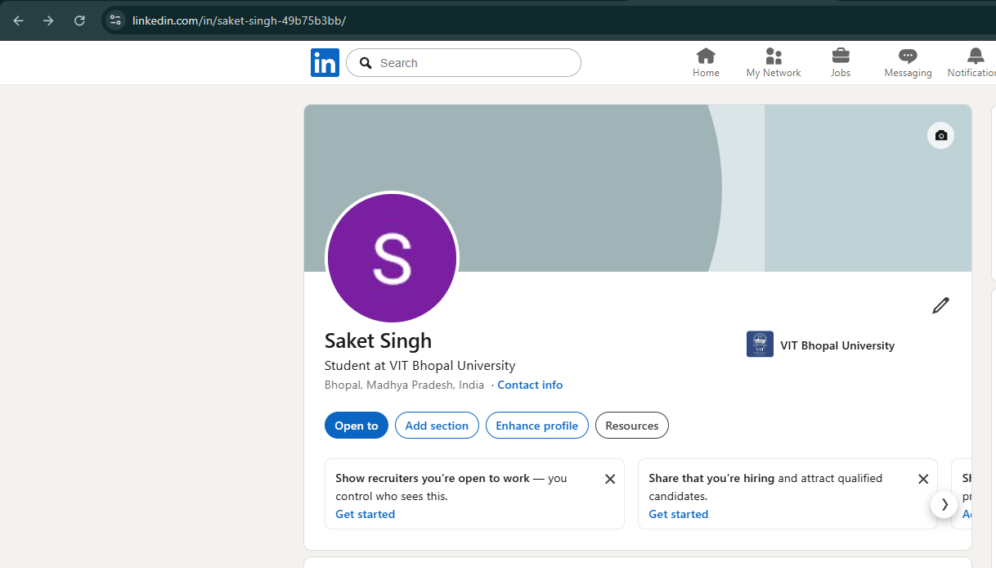
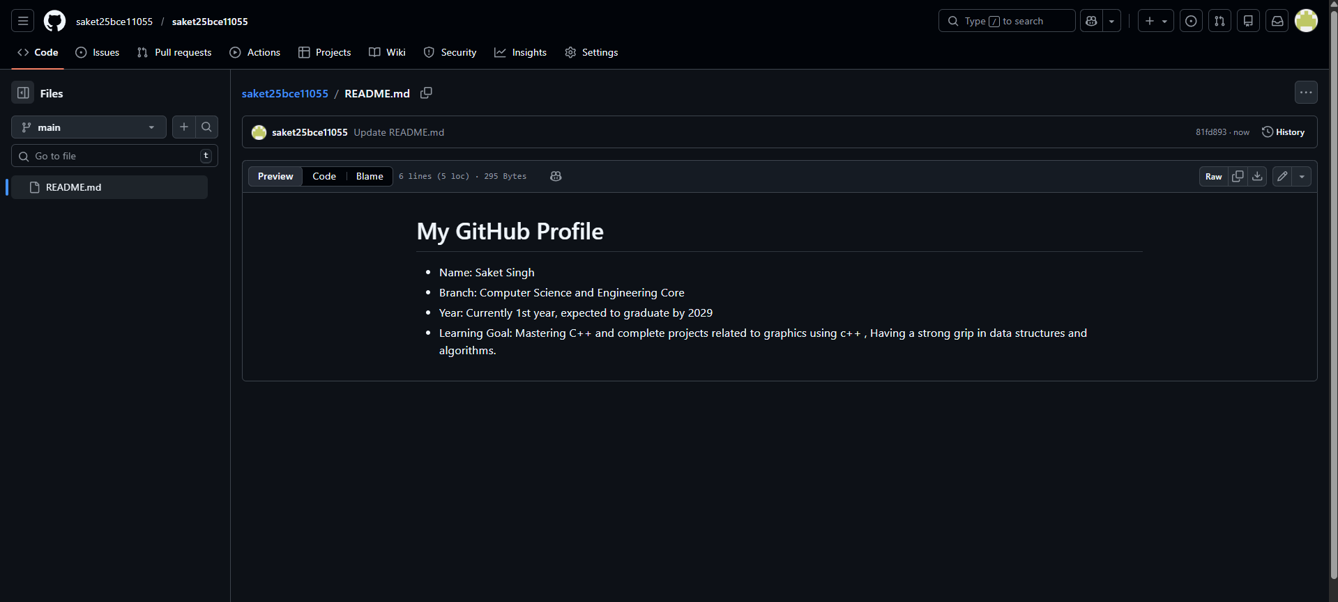

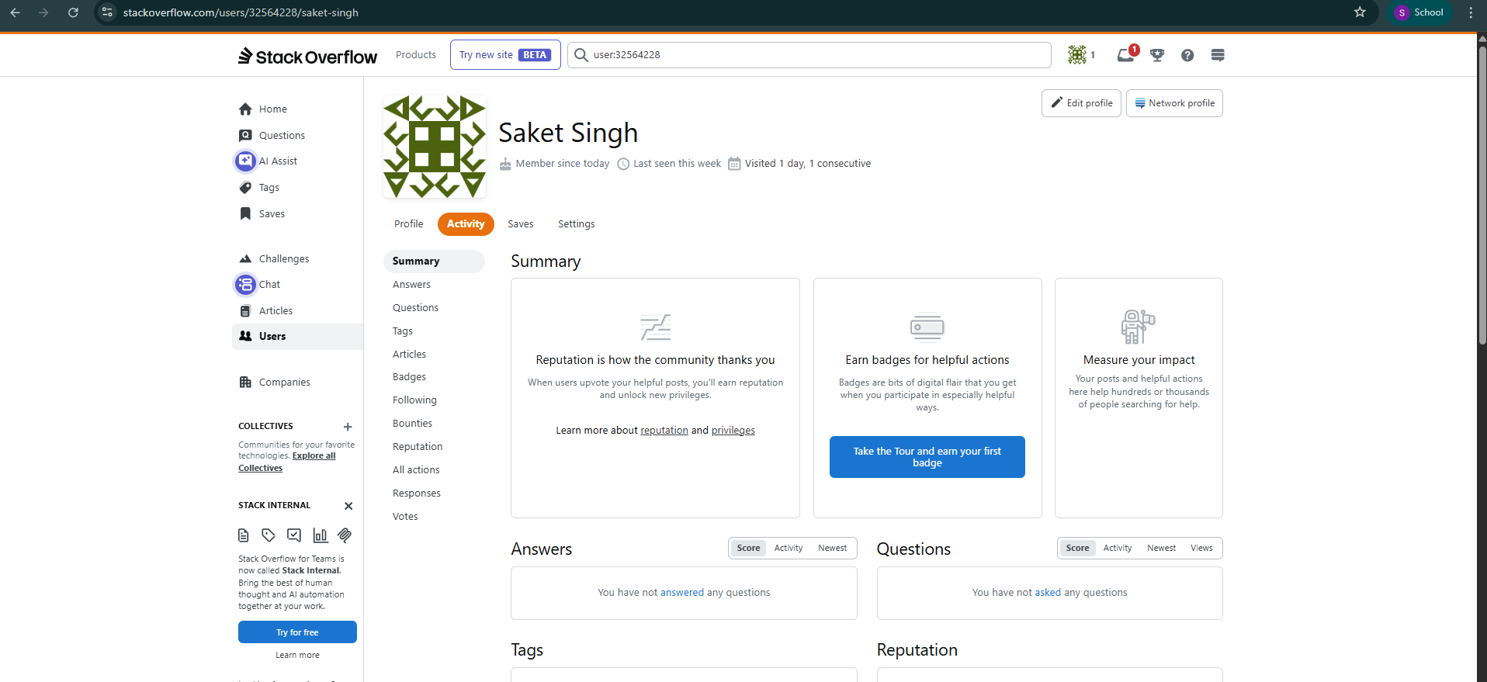

TASK 3 – Platform

For this task, I created an account on CodeChef and practiced beginner-level Python problems to strengthen my coding skills. CodeChef is a competitive programming platform that helps improve problem-solving ability, logical thinking, and coding efficiency through various challenges and contests. I completed a beginner Python program, which helped me revise basic concepts like input/output, conditionals, and simple logic building. Practicing on such platforms regularly will help me become more confident in coding and prepare for technical interviews in the future.
In addition to this, I created a Google Form as a “Digital Literacy Awareness Quiz” for my classmates. The form included five questions, with a mix of multiple-choice and short-answer types. This activity helped me understand how to use Google Forms for creating interactive quizzes and collecting responses efficiently through Google Sheets.
These tools will be very useful for my academic journey. CodeChef will help me continuously improve my programming skills, while Google Forms will assist in conducting surveys, quizzes, and data collection for projects and presentations.

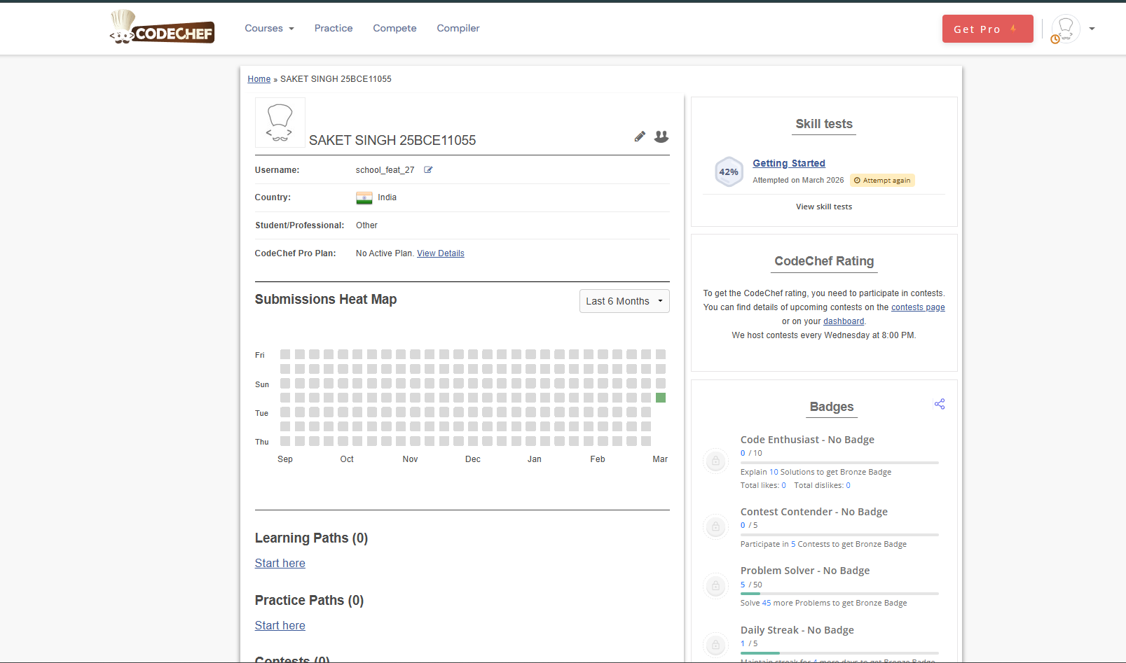
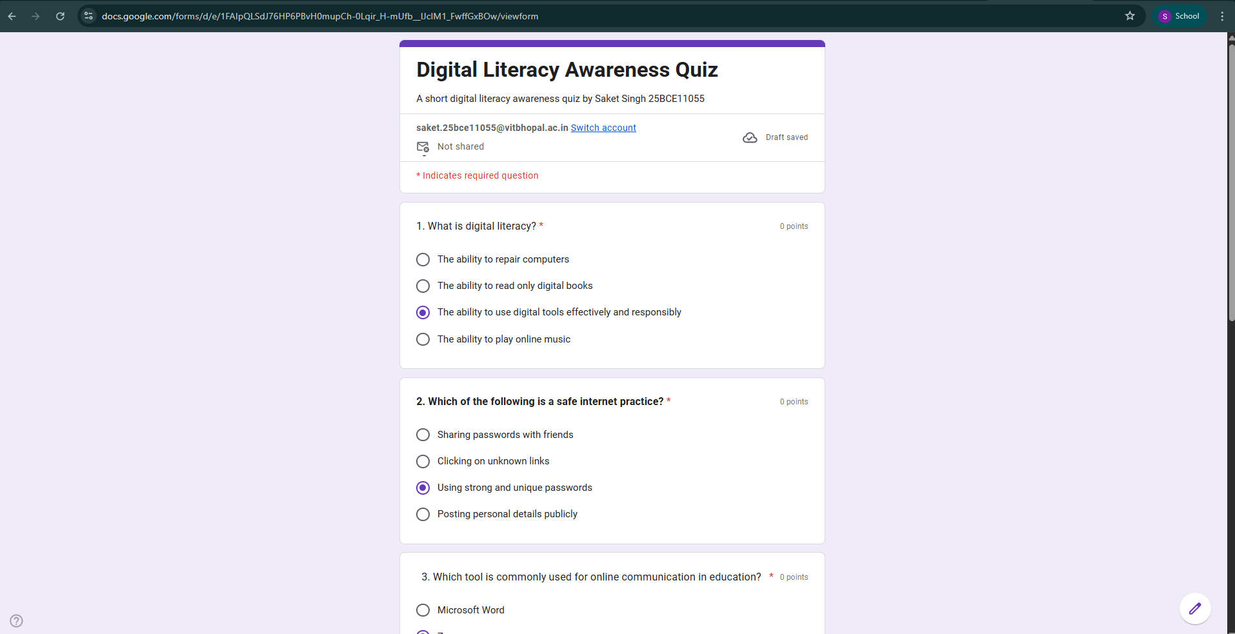

https://adocs.google.com/forms/d/e/1FAIpQLSdJ76HP6PBvH0mupCh-0Lqir_H-mUfb__IJcIM1_FwffGxBOw/viewform?usp=publish-editor

TASK 4 – Email Etiquettes

A situation where poor digital communication caused a problem can be seen in a college group project. One team member sent an important update about a change in submission format through a casual WhatsApp message late at night. Some group members missed the message, while others misunderstood the instructions. As a result, the group submitted inconsistent work, and their grades were affected. A similar incident happened to me during my group’s SST group discussion.
This problem occurred because the communication was unclear, informal, and not shared through an appropriate platform. It could have been avoided if the student had used a more formal and reliable method, such as email or a shared document, with a clear explanation of the changes. Additionally, confirming that all members had read and understood the message would have helped. This situation highlights the importance of clear, timely, and professional digital communication.

TASK 5 – CyberCrimes

While researching phishing, what surprised me the most was how convincing and realistic phishing messages can be. Many fake emails and websites look almost identical to official ones from banks or trusted companies, making it very easy for anyone to be tricked. I also found it surprising how attackers use urgency, such as warning that an account will be blocked, to pressure people into acting quickly without thinking.
As a result of this research, one habit I will personally change is being more cautious before clicking on any links or messages. I will make it a practice to verify the sender and check the URL carefully before entering any personal information. This will help me stay safer online and avoid falling victim to such scams.

CONCLUSION

This project helped me understand the importance of digital literacy in today’s world. I learned how to use digital tools effectively, communicate professionally online, and follow safe internet practices. It also made me aware of cybercrimes like phishing and how easily people can be targeted if they are not careful.
Through this project, I realized the importance of being responsible while using social media and maintaining a positive digital presence. I also understood how small habits, like verifying links or using strong passwords, can make a big difference in staying safe online.
Overall, this project improved my awareness and practical knowledge of using digital platforms wisely, which will be useful in both my academic and personal life.
REFERENCES

Tools Used: MS POWERPOINT, GMAIL, MS WORD
Platforms: Vityarthi , GitHub , CodeChef, Linkedin , etc
Various online articles used for cybercrimes , email etiquettes and other mentioned topics in this report

